H.T No
Regulations:
A15

Sreenidhi Institute of Science and Technology
(An Autonomous Institution)
Code No: 5W102 Date: 19-Jan-2019 (FN)

M.Tech I-Year I-Semester End External Examination, Jan/Feb-2019 (Supplementary)
ADVANCED FINITE ELEMENT ANALYSIS (CAD/CAM)

Time: 3 Hours Max.Marks:75

Note: a) No additional answer sheets will be provided.
b) All sub-parts of a question must be answered at one place only, otherwise it will not be valued.
c) Missing data can be assumed suitably.

Part - A Max.Marks:25

Answer all QUESTIONS.

1. | Show the eigen value problem finite element formulation and list the methods used for solving it. | [3M]
2. | Develop the transformation matrix used for conversion of space truss element co-ordinates from local to global system. | [3M]
3. | Show the triangular membrane plate element with nodal degree of freedom. | [3M]
4. | Develop the consistent mass matrix for a linear bar element. | [3M]
5. | Differentiate between steady state and unsteady state heat transfer problems by mentioning governing differential equations. | [3M]
6. | List the applications of invicid and incompressible flow problems. | [2M]
7. | Write the characteristics of stiffness matrix. | [2M]
8. | List the properties of eigen vectors. | [2M]
9. | Write the boundary conditions in conduction heat transfer problems. | [2M]
10. | Differentiate between finite element and finite difference methods. | [2M]
Part – B Max.Marks:50
ANSWER ANY FIVE QUESTIONS. EACH QUESTION CARRIES 10 MARKS.

11. |  | Find the eigen values and eigen vectors of the following matrix using the Jacobi method. 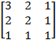 | [10M]
12. |  | Develop the element stiffness matrix for space truss element in global coordinate system. | [10M]
13. |  | Determine the stresses in the plate shown in figure using one triangular membrane element.  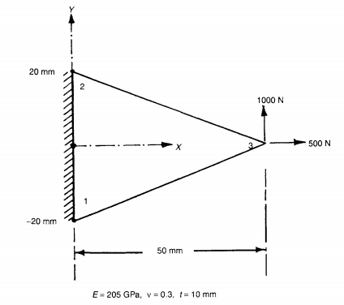 | [10M]
14. |  | The properties of the stepped beam shown in figure are:  Element 1: E=200 GPa, ρ= 7800 kg/m³, diameter=50 mm  Element 2: E=70 GPa, ρ= 2800 kg/m³, diameter=25 mm  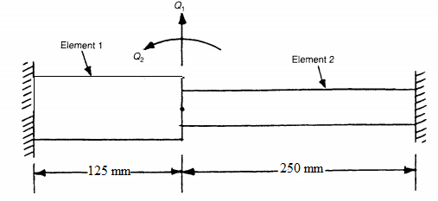 | [10M]
15. |  | Discuss the heat transfer problems with radiation. | [10M]
16. |  | Discuss the stream function formulation and it’s finite element solution. | [10M]
17. | a) | Find the inverse of the following matrix using the decomposition [A] = [U]^{T}[U], where [U]=Upper triangular matrix.  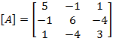 | [3M]
 | b) | Discuss briefly forced vibration response of beam. | [3M]
 | c) | Discuss briefly partial differential equations of steady state fluid flow problems. | [4M]

-- 00 -- 00 –

